Let us see how to use a query variable when **field parameter is enum type**.

## Step 0 − Download and Install Required Dependencies for the Project

Create new package.json file with below code and install all dependencies.

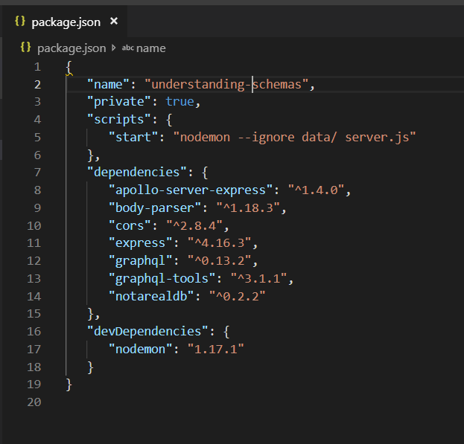

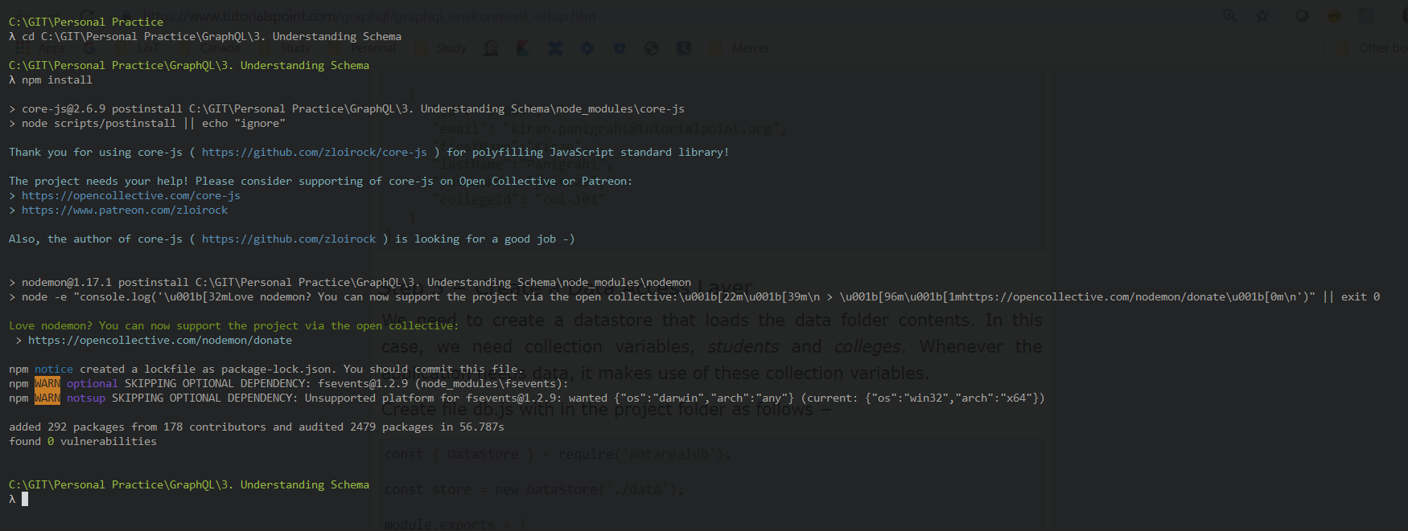

## Step 1 − Edit Schema File

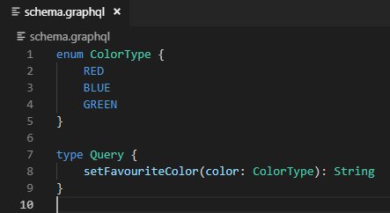

The *setFavouriteColor* function takes enum as input and returns a string value.

## Step 2 − Edit resolver.js File

The resolver function *setFavouriteColor* takes *root* and *args*.

The enum value passed to function at runtime can be accessed through args parameter.

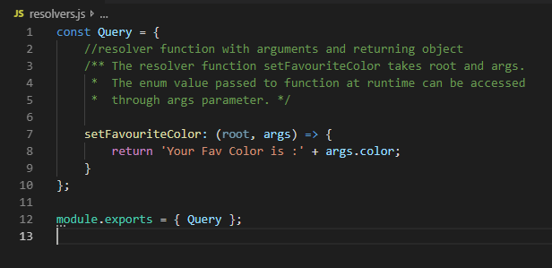

## Step 3 − Declare Query Variable in GraphiQL

The query is named **query_to_setColor** which takes a variable of the name color_variable of ColorType.

This variable is passed on to method setFavouriteColor.

## Step 4 − Run the Application

Create a server.js file.

